

Ranchi University, Ranchi

**ONLINE CAR BOOKING**

Submitted in partial fulfillment of the requirements for the award of the degree of Bachelor of Science

Computer Application/Information Technology Hons



Gossner College, Ranchi

**SUBMITTED BY :-**

**NAME : AYUSH KUMAR**

**UNI.ROLL NO. : 19BS5850249**

**DEPARTMENT : COMPUTER APPLICATION**

**SESSION : 2019-2022**

**COLLEGE : GOSSNER COLLEGE, RANCHI**

**CERTIFICATE**

I **Ayush Kumar**, university roll no - **19BS5850249** , department Computer Application (BCA), certify that project report entitled **ONLINE CAR BOOKING** in paper DSE4 is done by me and it is authentic work carried out by me at the Gossner College, Ranchi.

Sign. Of Student

Date –

This is to certify that the project report entitled **ONLINE CAR BOOKING** in paper DSE4 is done by **Ayush Kumar**, university roll no - **19BS5850249**, department Computer Application (BCA), is completed under my guidance.

Signature of guide

Date –

Guide Name –

Designation –

Examiner Course coordinator Principal

**ACKNOWLEDGEMENT**

I take this opportunity to thank Gossner College, Ranchi for giving me the privilege of working on such an interesting topic (Project Title).

I would like to express my sincere gratitude towards my guide …………………………..…. whose guidance has enriched my knowledge horizon and provided me all the necessary support without which the project would not have been success.

I am extremely grateful to all the teachers of B.Sc.CA & IT department, Gossner College, Ranchi for their priceless support which has helped me in making this project report and successfully completing the project that was allotted to me by the department.

I would also like to extend my gratitude to the Course Coordinator of B.Sc CA & IT department and Principal of Gossner College, Ranchi for providing me with all the facilities that was required to complete the project.

I would also like to thank other teacher/staff of college who have contributed greatly to the success of this project.

Finally, I wish to thanks all those who have directly or indirectly helped me during the course of project.

DATE - _________________ NAME - _________________________

UNIVERSITY ROLL NO. - ____________

DEPARTMENT - __________________

**INDEX**

1. **Introduction**

1.1 Feasibility Study.

1. **System Requirement and Specifications**

2.1 Hardware Requirement.

2.2 Software Requirement.

1. **About Modules**

3.1 Admin Module

3.2 Registration Module

3.3 Profile Management Module

**4. Data Flow Diagram and E-R Diagram**

4.1 Data Flow Diagram.

4.2 ER Diagram.

**5. Screenshots**

1. **Conclusion**

6.1 Future scope

6.2 References

1. **Source Code**

**INTRODUCTION**

**Online Car Booking** is website for car operators to manage day to day operations. The project is done for the car operator who has more than 100 cars in the city. The main problem they are facing is booking the car when customer is called. There is a lot of mismatch in the address or in handling or in billing. To solve this problem this project is developed. This project has options to store all the details of cars and customers. So when customer called they will feed the data in database, so easily we can allocate particular car particular customer. And based on this we can do can book the car.

**Objective** : The main objective of the Online Car Booking is to manage the details of Car and Customer. It manages all the information about Booking and Car. The project is totally built at administrative end and thus only the administrator is guaranteed the access. The purpose of the project is to build an application program to reduce the manual work for managing the Car, Booking, Customer.

**Type** : Web Applications

**Front-End** : HTML, CSS, JS.

**Back-End** : PHP, MySQL.

**FEASIBILITY STUDY**

Feasibility study is the first step before starting any project. The main aim of feasibility study is to determine whether developing the product is financially and technically feasible or not. In Feasibility study we also test whether the product would be profitable. The Feasibility study involves the analysis of the problem and collection of data which would be input to the system, the processing require to be carried in this data. The output data required to be produced by the system. The collected data are analyzed to arrive at the following:

1. **Technical feasibility**

Technical feasibility means whether the project is working in a perfect manner. It means the project must support or perform all the technical functions for which it is implemented. The project “**Online Car Booking**” through PHP TECHNOLOGY is technically feasible. This website is well capable of providing a user good interface thus this project is able to work in effective and efficient manner.

1. **Economical feasibility**

Economical feasibility is a term which is related to estimation of cost required for the project. This project is feasible under the economic condition.

1. **Legal feasibility**

Legal feasibility means the developing project must be legal. The way by which the product is going to be implemented must be legal. The project must perform a legal task. It must be acceptable worldwide. The project is not going to perform any tasks which are not lie under the condition of law. Thus the project must be legal to use and can be acceptable by the user.

**D) Operational feasibility**

Operational feasibility means the project must perform its operation perfectly. If the project is working properly then we can say that the project is Operational feasibility.

**SYSTEM REQUIREMENT AND**

**SPECIFICATION**

**2.1 HARDWARE REQUIREMENT**

This section will describe the hardware requirement which is at least necessary to run this website.



* **Processor**

The minimum requirement of processor is at least Pentium IV with 900 MHz processing speed. The speed of processor determines the time taken for the execution of the instructions. Higher processing speed leads to faster execution of the instruction.



* **RAM**

There should be minimum 256 MB of RAM available for the smooth functioning of the project. Higher memory leads in better results.



* **Hard disk**

There should be about minimum 40GB of hard disk for smooth functioning of the project and so the recommended hard disk space is 40 GB.

* **Cache Memory**

There must be about 512 KB of cache memory so that the accessing time can be better and compilation is easier.

**2.2 SOFTWARE REQUIREMENT**

* **Operating System**

Window XP, 7, 8 and other operating systems like Linux; Mac OS can also be used.



* **Programming Language**

HTML CSS

JavaScript PHP

MySQL

* **Back End**

PHP MySQL (XAMPP)

 

* **Project team size –** 3

**ABOUT MODULES**

**3.1 Admin Module**

“This is a Master creation Module. It will look after and control all the Appointment being created and posted. Once the Appointment are created and posted the admin has the authority to see and alter those Appointment .”

**3.2 Registration Module**

“This module is responsible for the registration of a new user. In this module the user register’s itself by entering the required information. This module also verifies the new user details with the previously registered users.”

**3.3 Profile Management Module**

“This module manages the profiles of all the registered users. In this module all the details of the registered users are stored. It creates a separate record for individual users about all the Appointment being created and posted.”

**DATA FLOW DIAGRAM**

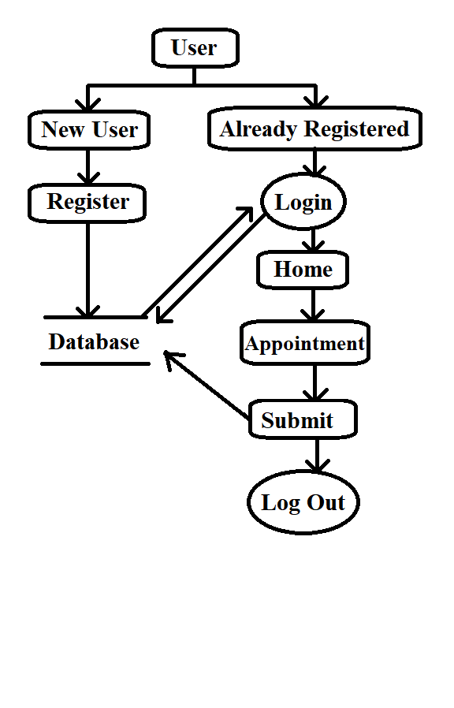

**E-R DIAGRAM**

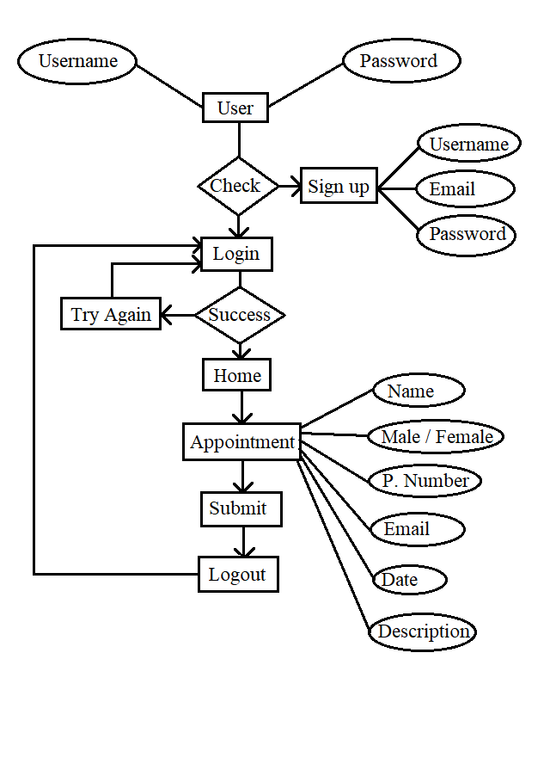

**SCREENSHOTS**

* The output screen where a user can **sign up** or **register** itself.

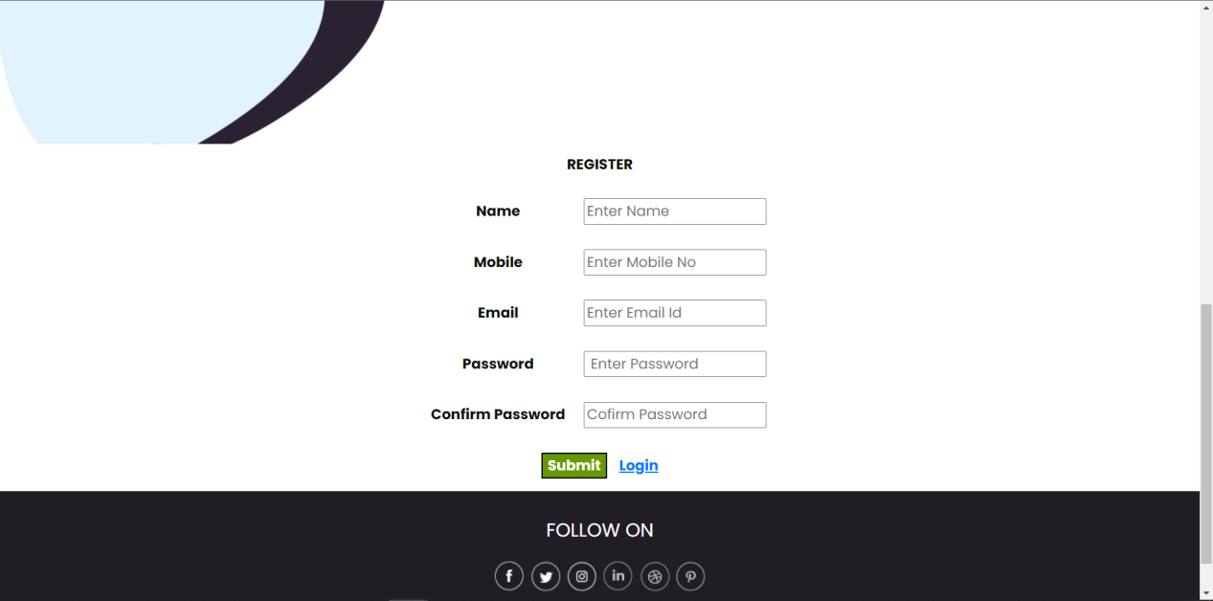

* The output screen of the **user login page**.

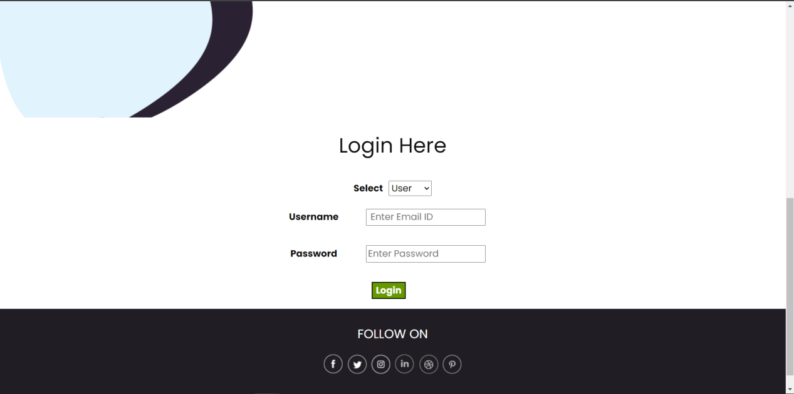

* The output screen of the **Admin login page**.

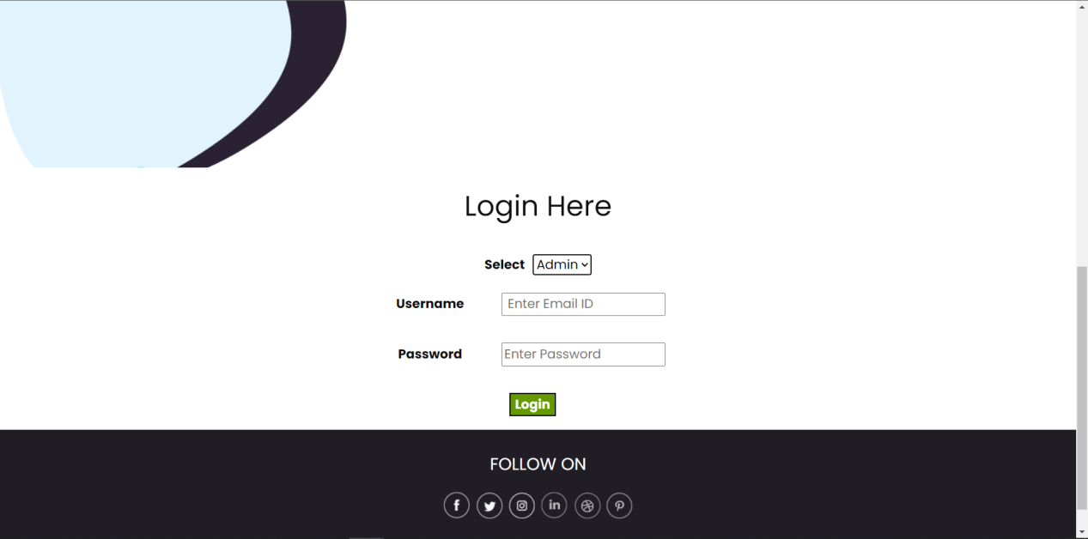

* The output screen of the **home page**.

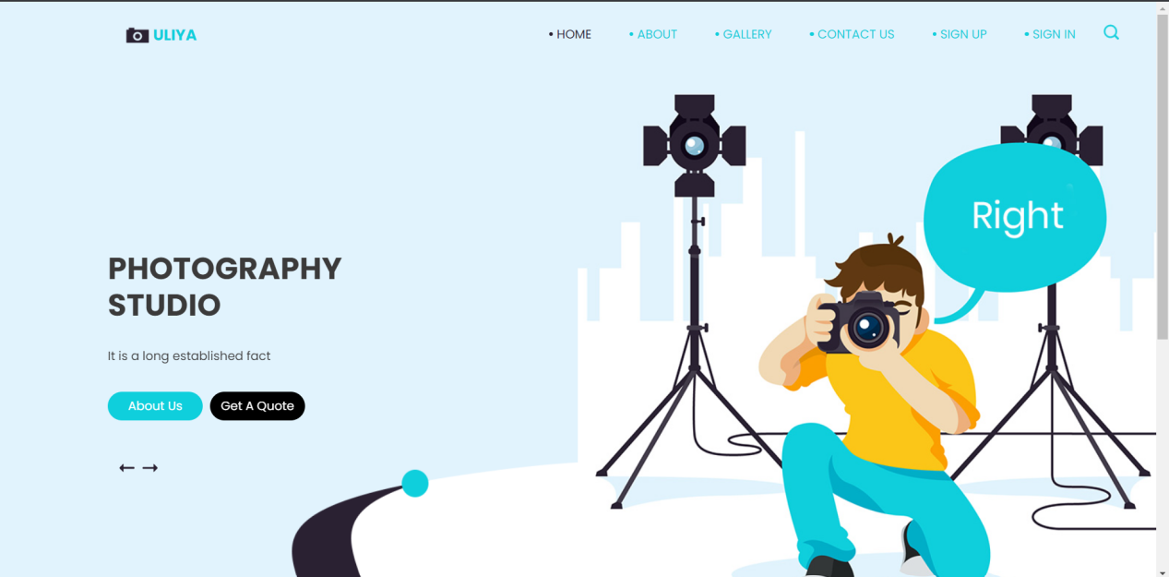

* The output screen of **Appointment** section.

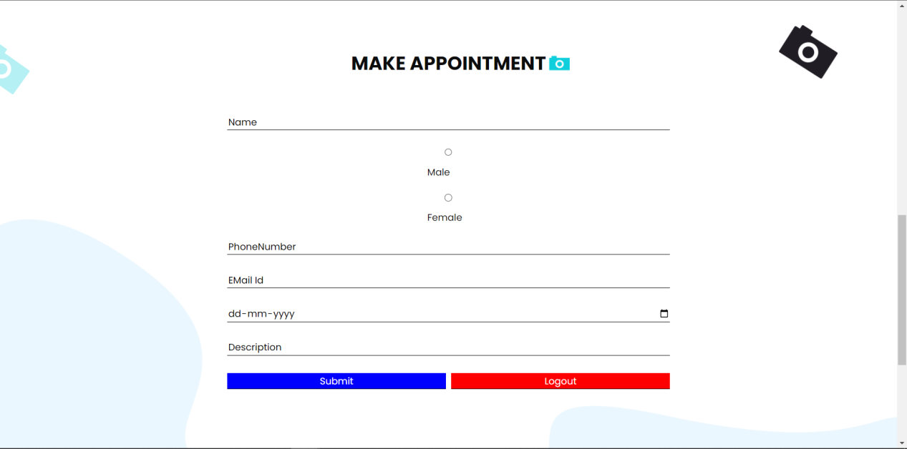

* The output screen of **About** section.

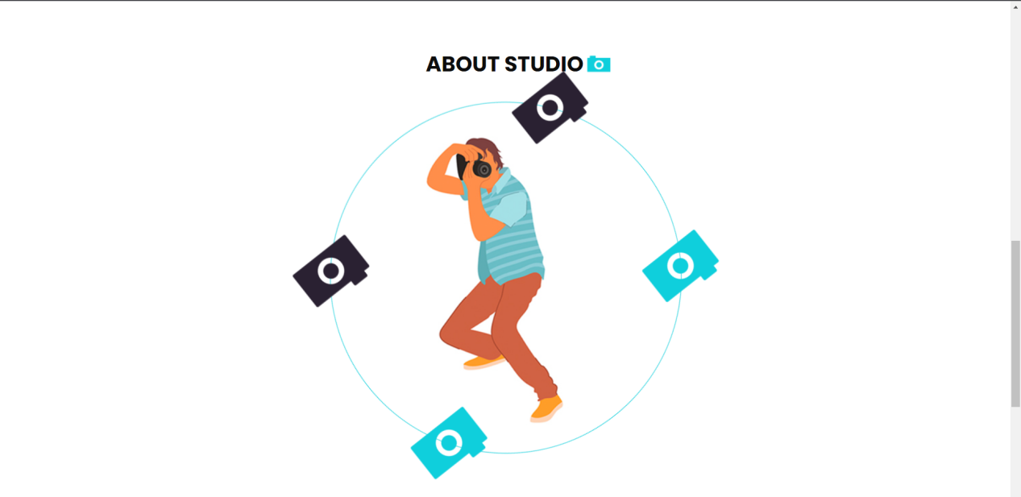

* The output screen of **Contact us** section.

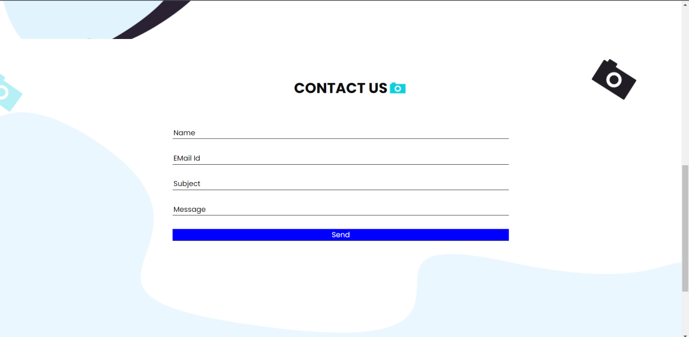

* The output screen of **Gallery** section.

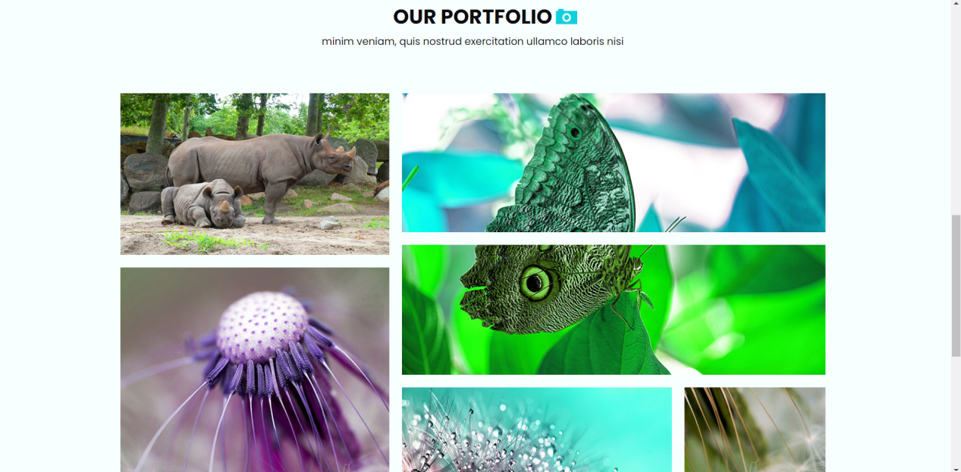

* The output screen of **Admin login** section.

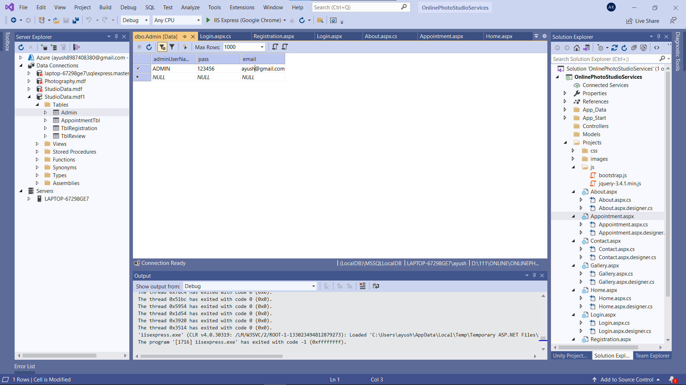

* The output screen of **User Login Admin** section.

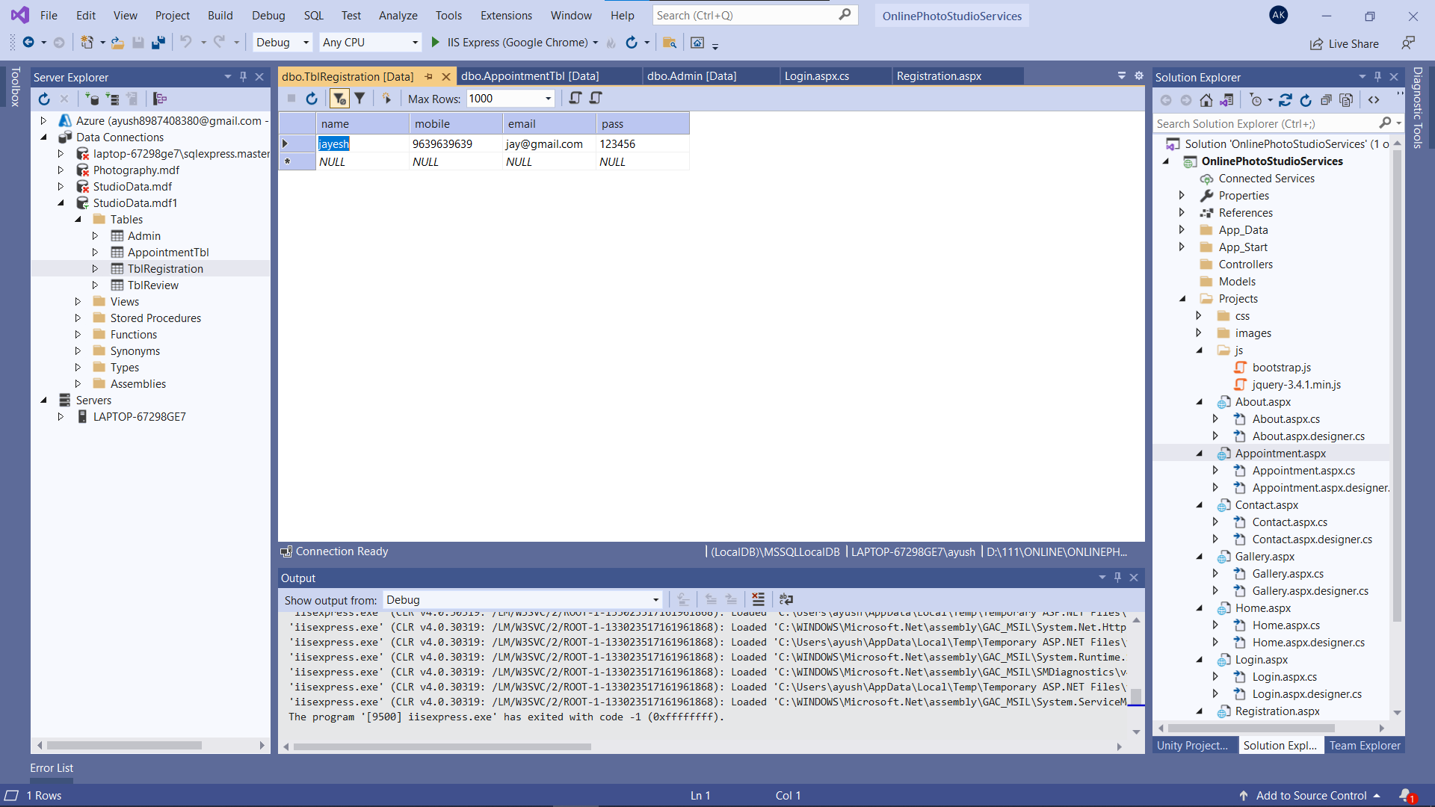

* The output screen of **Appointment Admin** section.

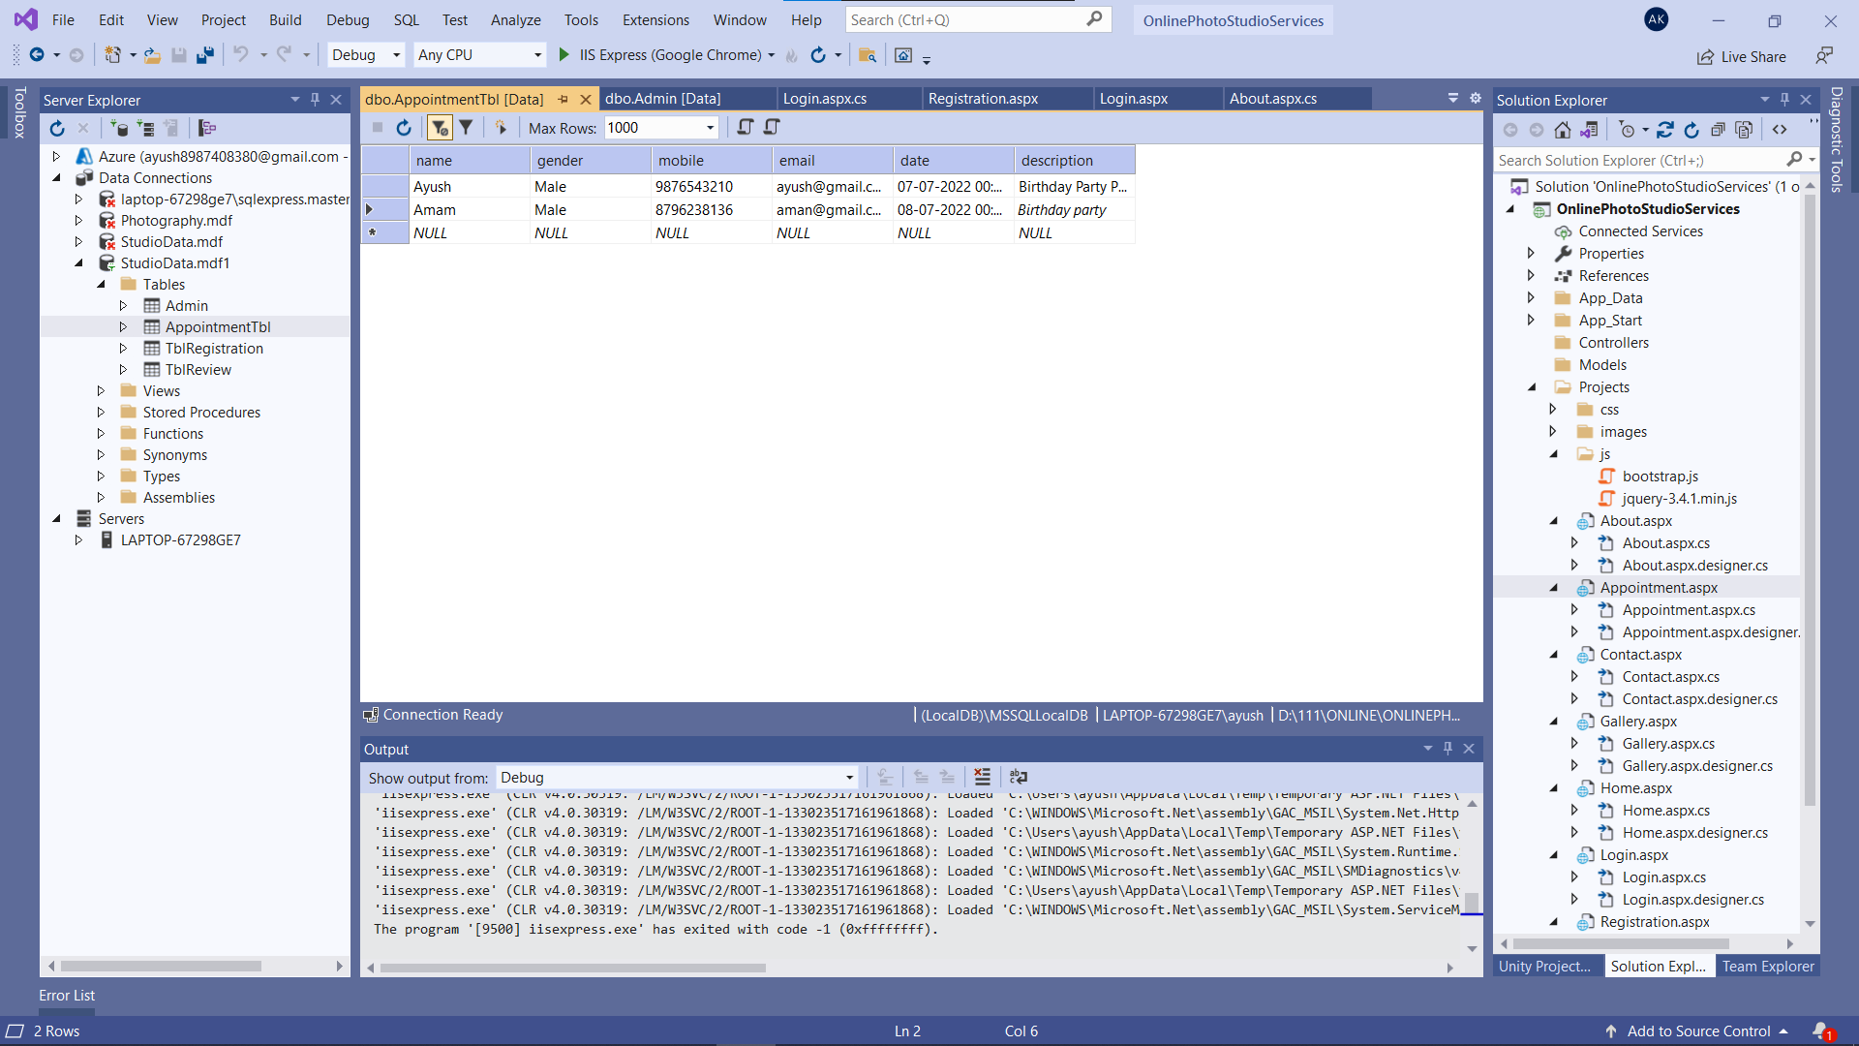

* The output screen of **Contact us Admin** section.

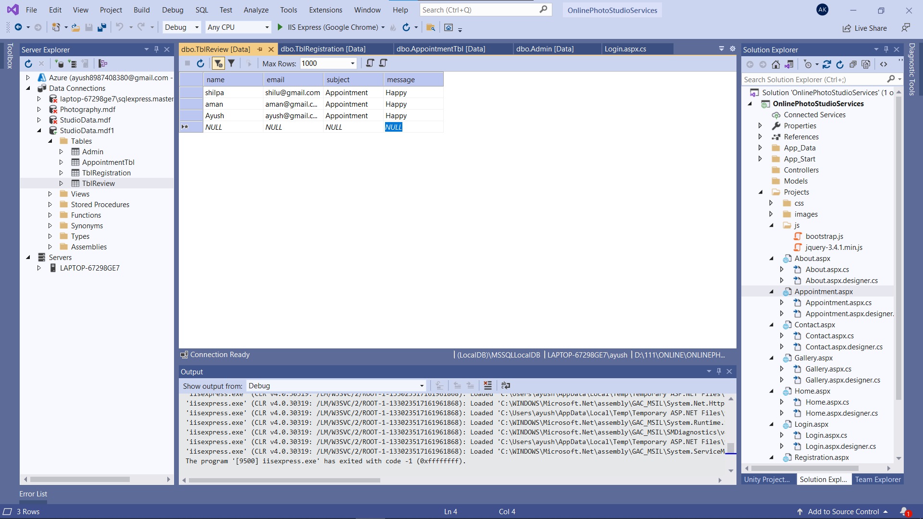

**CONCLUSION**

**(Future Scope And References)**

**6.1 Future Scope :**

“This Studio service can easily support any browser. Various updates can be performed in this website in coming future. This website will result in minimizing the gap among different users. This website gives a platform which results in an easy way of communication among different people from different areas”

**6.2 References:**

**Books:**

* The **COACH Visual Basic .NET** 2003 in 21 Days. – Steven Holzner, SAMS Publications. Mastering Crystal Report - BPB Publication.
* Crystal Report – The Complete Reference :- **Tata McGraw Hill** .
* **Programming in Vb.Net** – V Christy, University Science Press

**Web Sites:**

* [https://dotnet.microsoft.com/](https://www.php.net/)
* <https://www.w3schools.com/asp/>
* <https://stackoverflow.com/>

**SOURCE CODE**

* **UserMaster.Master**

<%@ Master Language="C#" AutoEventWireup="true" CodeBehind="UserMaster.master.cs" Inherits="OnlinePhotoStudioServices.Projects.UserMaster" %>

<!DOCTYPE html>

<html>

<head runat="server">

<meta charset="utf-8" />

<meta http-equiv="X-UA-Compatible" content="IE=edge" />

<!-- Mobile Metas -->

<meta name="viewport" content="width=device-width, initial-scale=1, shrink-to-fit=no" />

<!-- Site Metas -->

<meta name="keywords" content="" />

<meta name="description" content="" />

<meta name="author" content="" />

<title>User Master</title>

<link rel="stylesheet" type="text/css" href="css/bootstrap.css" />

<!-- fonts style -->

<link href="https://fonts.googleapis.com/css?family=Poppins:400,700&display=swap" rel="stylesheet">

<!-- Custom styles for this template -->

<link href="css/style.css" rel="stylesheet" />

<!-- responsive style -->

<link href="css/responsive.css" rel="stylesheet" />

</head>

<body>

<form id="form1" runat="server">

<div>

<div class="hero_area">

<!-- header section strats -->

<header class="header_section">

<div class="container-fluid">

<div class="row">

<div class="col-lg-11 offset-lg-1">

<nav class="navbar navbar-expand-lg custom_nav-container ">

<a class="navbar-brand" href="Home.aspx">

<img src="images/logo.png" alt="">

<span>

Uliya

</span>

</a>

</a>

<button class="navbar-toggler" type="button" data-toggle="collapse" data-target="#navbarSupportedContent"

aria-controls="navbarSupportedContent" aria-expanded="false" aria-label="Toggle navigation">

<span class="navbar-toggler-icon"></span>

</button>

<div class="collapse navbar-collapse" id="navbarSupportedContent">